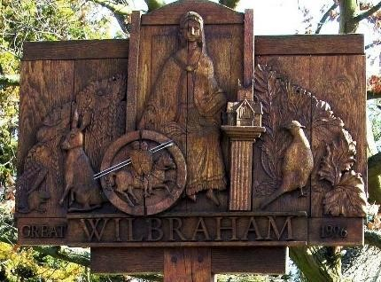

**GREAT WILBRAHAM PARISH COUNCIL**

**Chairman: Dr Hilary Burton. Clerk: Mrs Sam Chambers-Turner**

**41 Stow Road, Stow-Cum-Quy**

**CB25 9AD**

**Tel: 07369248998**

**Email: clerk@greatwilbrahamparishcouncil.gov.uk**

**NOTICE OF THE ANNUAL PARISH MEETING OF GREAT WILBRAHAM**

**AGENDA**

**Tuesday 22 April 2025 at 7.30 pm**

**(Refreshments are available from 7.00 pm)**

1. **Welcome and introductions to Parish Councillors**
2. **Reports and updates from the Chairman of the Parish Council, Chairman of the Highways, Transport and Cycleways Committee and the Chairman of the Environment and Biodiversity Group.**

*Each followed by an opportunity to ask questions and make suggestions.*

1. **Report and update from County and District Councillors**

*Each followed by an opportunity to ask questions.*

1. **Roundtable discussions on key village topics.**

*An opportunity to meet other residents, representatives of village organisations and Councillors, discuss important upcoming issues and raise any other concerns or ideas.*

1. **Feedback, and discussion of next steps.**
2. **Close of meeting at 9.30 pm followed by informal discussion.**

*Hilary Burton*

**Chairman**

**7 April 2025**