AWARDS FIRST PRIZE: 50p (3 pts)
SECOND PRIZE: 30p (2 pts)
THIRD PRIZE: 20p (1 pt)
Special prizes of £1.00 are given for the best exhibit in the Vegetable, Fruit and Flower sections.
The following awards WILL BE PRESENTED AT 3.45 PM and will be held for 1 year:
The Stephenson Cup - awarded to the Exhibitor with the Highest Points total in Classes 1-22
The Richard Wright Cup - awarded to the Winner of Class No. 22 “Spud in the Bucket” competition
The Les Potter Cup - awarded for the Highest Points total in the Fruit section (Classes 23-29)
The Rose Bowl - awarded to the Winner of Class No. 30
The Brian Fisher Salver - awarded for the Highest Points total in the Flower section (Classes 30-45)
The David Waters Memorial Cup - awarded to the Best Fuchsia grown from plug plant supplied (Class 41)
The Show Helpers Cup - awarded for the Highest Points total in the Flower Arrangement section (Classes 46-50)
The Social Club Cup - awarded for the Highest Points total in the Produce section (Classes 51- 61)
The 2012 Diamond Jubilee Rose Bowl - awarded for the Highest Points total in the Arts & Handicrafts section (Classes 62-69)
The Doris Franklin Cup – awarded for the Highest Points total in the Photography section (Classes 70-74)
The Thistle Tankard - awarded for the Highest Points total in the Under 12’s section (Classes 75-83)
The Junior Cup - awarded for the artwork judged to be the most outstanding in the Under 12’s section
Exhibitors who wish to collect their entries should do so at 3.30pm. If you are willing to leave your entries for auction, these will be most gratefully accepted and PROCEEDS WILL GO TO THE HALL FUNDS.
DO NOT MISS THE FRUIT & VEGETABLE AUCTION AT 4.00 PM
Any queries - Rosie White on 01223-881293/07757982934 or rosiewhite77@hotmail.com

The Wilbrahams and Six Mile Bottom
VEGETABLE, FLOWER AND PRODUCE SHOW
2024
Memorial Hall, Great Wilbraham
Saturday 13th July, at 2 pm
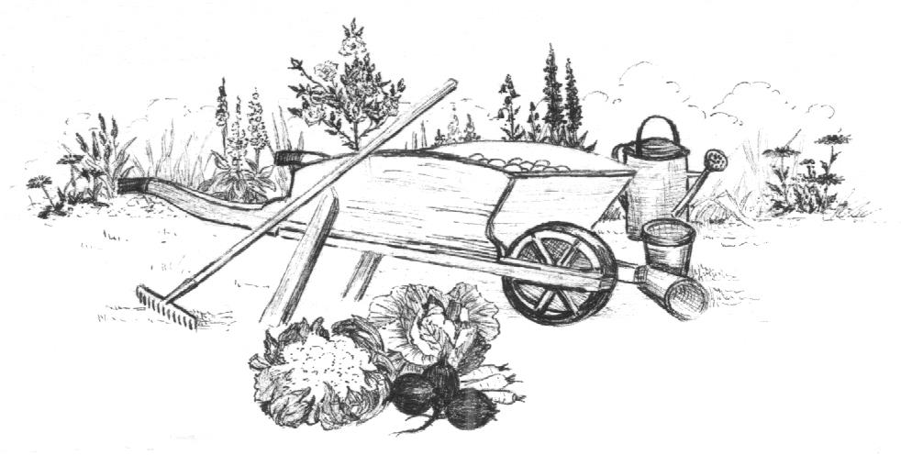

Teas Raffle
AUCTION OF DONATED EXHIBITS AT 4.00 pm
ALL PROCEEDS TO HALL FUNDS

Admission: Adults £1 Under 18s Free

The Hall is open for receiving entries on Saturday 13th July from 9.00 am to 11.00 am. No exhibits will be accepted after 11.00 am and all exhibitors MUST leave the Hall by 11.15 am. Exhibitor’s entrance fee: Adults 20p per item. NOTE Under 18s FREE

Vegetables
1. 5 pods of broad beans
2. 5 pods of peas or mangetout
3. A bunch of 5 radishes (one variety)
4. 1 lettuce, root intact (any variety)
5. 3 potatoes (same variety)
6. 5 salad onions with tops on
7. 1 cucumber (any variety)
8. 3 carrots, tops trimmed
9. 5 French or dwarf beans
10. 3 bulbs of garlic
11. 3 beetroot, tops trimmed
12. 2 courgettes (4-8”/10-20cm)
13. 3 tomatoes with stalk (same type)
14. 5 shallots
15. 5 runner beans
16. 3 onions, tops trimmed and tied
17. The longest bean!
18. 1 cabbage with 2-3”/5-7.5cm stem
19. Tray, trug or basket of mixed vegetables, at least 5 different varieties
20. 3 varieties of herbs (3 stems of each)
21. Exhibit of any vegetable not included in the schedule
22. “Spud in a Bucket” competition (see Warbler article for details)
Fruit
23. 7 raspberries
24. 5 strings of blackcurrants
25. 5 strings of redcurrants
26. 7 gooseberries
27. 3 sticks of rhubarb
28. Exhibit of any fruit not included in the schedule
29. Longest stick of rhubarb
Flowers
30. A specimen rose (Rose Bowl Award)
31. 5 stems of garden flowers – each different
32. 3 stems of roses, large flowered
33. 5 stems of sweet peas, single colour or mixed
34. 3 stems of cluster-flowered roses
35. 3 stems of flowering shrub (mixed or the same)
36. 1 dahlia bloom (any variety, any size)
37. 3 stems of herbaceous perennials (mixed or the same)
38. 3 stems of dahlias (mixed or the same, any size)
39. 3 stems of foliage plant (mixed or the same)
40. A rose – chosen for scent
* See Warbler article for details (class 41)
41. 1 fuchsia grown from plug plant supplied
* See details in ‘Rules’ Section (classes 42-45)
42. A flowering pot plant
43. A foliage pot plant
44. Cactus/cacti or succulent(s) in any container
45. Single outdoor plant in a pot
Flower Arrangements * See note in ‘Rules’ section
46. Summer sunburst floral table arrangement (foliage /accessories allowed)
47. An arrangement in a recyclable article e.g. tub, tin, pot, jar, bottle
48. “Say it with flowers” – A small gift bag of flowers for a birthday
49. A ‘Fiery’ arrangement for the Summer Olympics (Flowers and or foliage in any vessel)
50. A petite arrangement (overall max size 9”/23cm)
Produce * See note in ‘Rules’ section (Classes 55-61)
51. 6 hen or 6 bantam eggs
52. 1 jar of jam or jelly (any variety)
53. 1 jar of marmalade (any variety)
54. 1 jar of savoury preserve (e.g. chutney, pickle, relish)
55. 1 loaf of bread or 4 bread rolls (any type)
56. 4 pieces Flapjack
57. Lemon drizzle cake any size/shape or 4 pieces if traybake.
58. “Olympic Sprint” Chocolate Fudge Cake (as per recipe)
59. 4 scones (any type)
60. Victoria Sandwich (jam or equivalent filling only)
61. 5 Cheese straws/twists (either your own recipe or use/adapt the one given!)
Arts and Handicrafts * See note in ‘Rules’ section
62. A drawing or painting (any medium)
63. An item of patchwork/quilting
64. Any sewn/stitched item
65. An item of knitting
66. An item of crochet, lace, knot work or beadwork
67. An item of tapestry, cross stitch or needlepoint
68. An item of hard handicraft (e.g. woodwork, pottery, metalwork)
69. Any other craft item not included in the schedule
Photography * See note in ‘Rules’ section and Warbler article from Andrew Evans
70. Landscape
71. Old and New
72. Buildings or Architecture
73. Patterns
74. Light and Dark
Children’s (Under 12’s) section
75. Under 5’s only A nature Collage (based on the book 'The Boy With Flowers in his Hair' by Jarvis)
76. A nature Painting (based on Henri Matisse 'Composition on a Green Ground')
77. A nature Sketch e.g. bird, flower, tree, insect, leaf
78. A nature Photograph to be displayed; examples as Class 77
79. Miniature forest on e.g. Plate/Tray/Board - forage for sticks/leaves/flowers to use in your creation
80. A painting or drawing any subject
81. A Lego/Knex/Mobilo model
82. Create your own Olympic award medal using e.g. modelling clay
83. Grow a plant from seed (provided by Rosie White)

Recipe for “Olympic Sprint” Chocolate Fudge Cake (Class 58)
(Takes 20 minutes to make and 20 minutes to bake!)

Ingredients:
150g (5 oz) plain chocolate
125g (4½ oz) butter
125g (4½ oz) plain flour sieved
200g (7 oz) caster sugar
3 eggs beaten

Method:
1) Preheat oven to 230°C (conventional oven) 450°F Gas Mark 8. Grease and base-line 18cm (7inch) round spring clip or loose bottomed cake tin/deep sandwich tin.
2) Break chocolate into pieces and place with butter in heatproof bowl over a pan of simmering water. Stir until melted. Remove bowl from pan and leave to cool.
3) Mix flour and sugar together in a large bowl and fold in beaten eggs.
4) Add cooled chocolate mixture, stirring gently until thoroughly combined.
5) Pour/spoon mixture into prepared tin and spread out evenly.
6) Bake on middle shelf for 20 minutes until just firm to the touch.
7) Leave cake in tin until completely cold then loosen from side of the tin and remove carefully, keeping top side up. Place on white paper plate for the Show.

NOTE The cake may sink slightly and crack as it cools but don’t worry, this is normal and will be deliciously gooey in the middle!
May be made 2-3 days in advance if stored in an airtight container (or freeze up to 1 month)

Optional Recipe for Quick and Easy Cheese Straws (Class 61)

Ingredients:
170g (6 oz) self-raising flour
Pinch salt
70g (2½ oz) margarine
85g (3 oz) finely grated cheddar cheese
1 medium egg beaten with 1 dessert spoon milk

Method:
Preheat oven to 180°C (conventional oven) 350° F Gas Mark 4
1) Mix flour and salt and rub in the margarine.
2) Mix in the grated cheese and make a stiff paste with the beaten egg and milk.
3) Roll out thinly and cut into narrow strips 1-1.5cm wide and about 15cm long.
4) Place on a greased baking tray and prick over with a fork.
5) Bake for 15-20 minutes until well browned.
6) Leave to cool in tray.

RULES
- Number of entries in each class limited to two per exhibitor (except Classes 22 and 41 which are limited to one per exhibitor).
- If there is only one entry in a class, the prize will be left to the judges’ discretion. The judges may withhold awards if, in their opinion, exhibits do not reach reasonable standards.
- Please read and interpret the meaning of the schedule to avoid disappointment or disqualification. The judges’ decision is final.

Notes:
- All exhibitors are on trust that their entries are MADE BY THEMSELVES OR GROWN IN THEIR OWN GARDEN IN THE WILBRAHAMS OR SIX MILE BOTTOM, except classes 42-50.
- Classes 42-45 must have been owned by the Exhibitor for at least 8 weeks.
- Classes 55-61 are to be exhibited on a white paper plate and covered with transparent film or a polythene bag.
- Classes 62-69 must be Exhibitor’s own work and not previously shown.
- Classes 70-74 to be sent electronically by email to vfpphotos@gmail.com – deadline midnight Wednesday 10th (3 days before the Show) - to be displayed at the Show on screen.

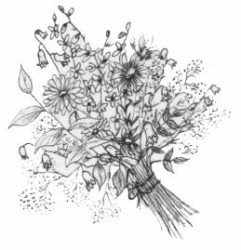

ENTRY FORM
If you would like your prize money to be donated to Memorial Hall funds please tick the box

Name .........................................
Address ..........................................................................................
Class No. | Exhibit | Fee
Please bring this completed form with your exhibits on the morning of the show
ENTRY FORM
If you would like your prize money to be donated to Memorial Hall funds please tick the box

Name .........................................
Address ..........................................................................................
Class No. | Exhibit | Fee
Please bring this completed form with your exhibits on the morning of the show

