Thursday 23rd May 2024 7.30pm
Christina Koning
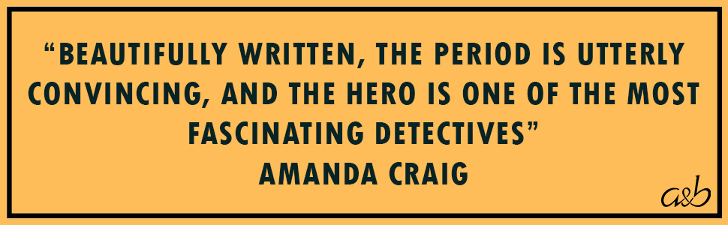
Christina Koning is an award-winning novelist, journalist and academic. She was born in Kuala Belait, Borneo, and spent her early childhood in Venezuela and Jamaica. After coming to England, she was educated at the University of Cambridge, Newcastle College of Art, and the University of Edinburgh.
She has worked extensively as a travel writer and literary critic and was three times a judge for the Society of Authors' McKitterick Prize, and Chair of Judges for Girton College's Ridding Reading Prize for several years -- mostly recently in 2023.
As an academic, she has taught Creative Writing at the University of Oxford and University of London, and was the 2014-15 Royal Literary Fund Fellow at Newnham College, University of Cambridge.
Christina Koning has two grown-up children and now lives in Cambridge.

