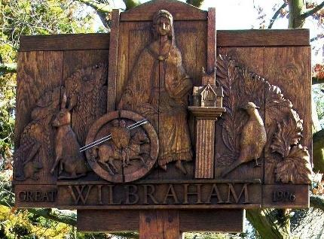
GREAT WILBRAHAM PARISH COUNCIL
Chairman: Dr Hilary Burton. Clerk: Mrs Sam Chambers-Turner 41 Stow Road Stow-Cum-Quy CB25 9AD Tel: 07369248998 Email:clerk@greatwilbrahamparishcouncil.gov.uk
NOTICE OF A MEETING OF THE PARISH COUNCIL
To Members of the Council:
I hereby give notice that a meeting of Great Wilbraham Parish Council will be held at Wilbrahams’ Memorial Hall on Tuesday 28th May 2024 at 5.30pm.
You are hereby summoned to attend for the purpose of transacting the following: Members of the public and press are invited to attend.
On behalf of Sam Chambers-Turner Clerk to the Parish Council 16 May 2024

AGENDA FOR MEETING 23
372 Apologies for Absence
(LGA 1972 s85(1))
373 Members Declaration of Interest for Items on the Agenda and Requests for Dispensation (Localism Act 2011 s31 s33)
374 Planning Matters
Planning Applications
24/01759/FUL Land at the back of 29 Frog End Great Wilbraham Cambridgeshire CB21 5JB. Erection of a self/custom build detached 1.5 storey dwelling.
22/04676/HFUL 27 Temple End. S73 to vary condition 2 (Approved plans) of planning permission
22/04677/LBC 27 Temple End. S19 to vary condition 2 (Approved plans) of listed building consent
24/01483/HFUL 27 Temple End. Installation of 2 No. Air Source Heat Pumps (ASHPs) within the rear garden
375 Agenda Item for the Next Meeting
Any business and payments, to be considered at Parish Council meetings must be delivered to the Clerk for inclusion on the agenda at least 7 days prior to the meeting
376 Date of Next Meeting
9th July 2024, Full Parish Council at Wilbrahams’ Memorial Hall.

