The Wilbrahams and Six Mile Bottom Vegetable, Flower and Produce Show

‘Spud in a Bucket’ competition 2024

Here’s how the competition goes:
- Pick up your chitted potato, mid-March, from Trish Davis,
13, Toft Lane, GW. (+ 20p entry fee)

- Plant into a 14L bucket (no smaller, no bigger!)
(Buckets this size are available from Trish at cost price of £1

- Tend and grow. Remove tops a few days before the Show.

- Take your buckets, with the potatoes still in them, and leave to the right in Rosie White’s driveway at 13, High St, GW.

- The buckets are emptied, and the potato tubers are weighed.
The winner is the one with the heaviest crop of potatoes and will be awarded the Richard Wright Cup.

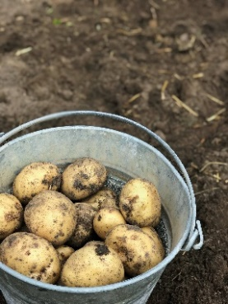
01223 880854/ 07739 415918/ trishbdavis@hotmail.com
01223 881293 /07757 982934/ rosiewhite77@hotmail.com

The spuds are ready to collect!
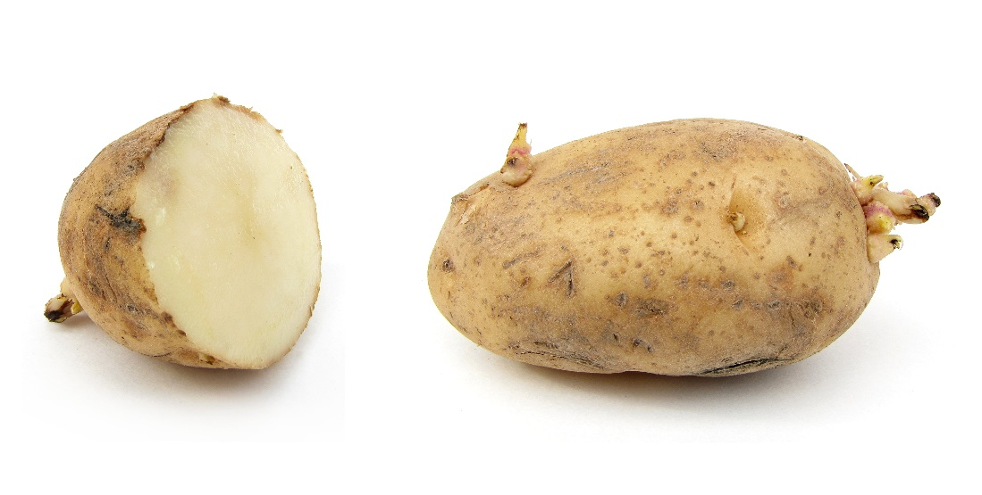
Call at 13, Toft Lane GW to collect
Or to reserve one for collection before Easter
Call Trish on 07739 415918
or
Email trishbdavis@hotmail.com

