FIRST RESULTS FROM THE MVAS UNITS

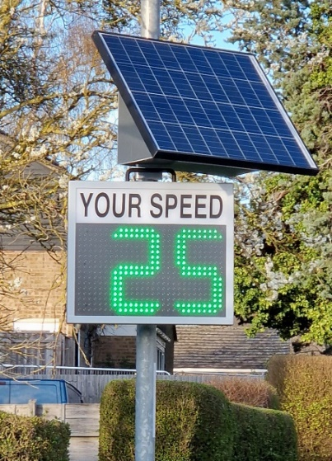
Another acronym, MVAS: Mobile Vehicle Activated Sign! An MVAS unit counts the number of vehicles passing and displays their speed. These units will play a key part in the campaign to slow traffic travelling through the village.

The village has 3 MVAS units with solar panels, made possible by the generous sponsorship of Low Carbon, a privately-owned investment company, active in large-scale solar energy projects, which manages the solar park situated across the A11 at the end of Mill Road.

The first of the MVAS units has been mounted in High Street since late March and collects data on traffic travelling from Fulbourn towards the triangle. It has been programmed to flash speeds from 15 to 45mph (a display of speeds above that may encourage boy- and girl-racers), and rewards or warns drivers with a message or a smiley face depending on their speed. Interesting data have been collected, including statistics from when the display was turned off (the numbers of vehicles and speeds were still being measured).

Below is a summary of the results for the first 7 fortnights.

696: Positioned outside 52 High Street. Direction from Fulbourn to Triangle
Date | Symbol | Total No.  Vehicles | Daily Av.  No. | Av. Speed | % Over 30mph | Max. Speed
25.3–8.4 | Thank You | 7540 | 539 | 25mph | 13.87 | 52mph
8.4–22.4 | Thank You | 7706 | 550 | 25mph | 13.80 | 50mph
22.4–6.5 | Smiley | 7469 | 533 | 25mph | 14.57 | 58mph
6.5–20.5 | None | 7949 | 568 | 26mph | 19.23 | 58mph
20.5–3.6 | Thank You | 7893 | 564 | 25mph | 13.61 | 62mph
3.6-17.6 | Smiley | 8785 | 628 | 25mph | 14.75 | 72mph
17.6-01.7 | None | 8596 | 614 | 26mph | 18.96 | 57mph

600 vehicles a day is a lot of traffic, and remember this is from Fulbourn, in one direction only. A similar number of vehicles is likely to be travelling in the opposite direction towards Fulbourn, and these will be measured when the MVAS unit is moved.

It is encouraging to see that the average speed of traffic passing the MVAS unit is 25mph, still too fast for many of us, but it is worrying that the speed increases when the display was switched off. Of more concern is the number of cars exceeding the 30mph limit. There were about 14% (1 in 7) of vehicles travelling at these speeds when the display was on, but the number increased to 19% (1 in 5) when the display was switched off.

Figures of particular concern are those in the final column showing the highest speed in each fortnight. The 72mph was measured late on a Sunday evening and is both dangerous and inexcusable. The vehicle driving at 57mph was travelling through the village – including past the playground - between and 10am and 11am on a Monday when children would have been out and about.

A second MVAS unit is now in place in Church Street by the playground providing data on traffic driving towards Little Wilbraham. At the time of writing, we have only one set of results and it will be better to wait until we have more before discussing them in detail. However, from our first readings, the number of vehicles is far higher than in High Street at about 1000 a day. Average speeds are similar to those in High Street although a smaller proportion of vehicles appears to be travelling at speeds above 30mph.

That last sentence is important. As mentioned earlier, the principal purpose of the MVAS units is to calm traffic, to slow vehicles down. The limited data already generated show that the units are achieving this, and further confirmation can be obtained simply by watching the displays on the units. It is particularly striking in Church Street. Traffic enters the detection zone by Church Close and the display begins flashing at that point. Vehicles can be seen slowing, often dramatically, from there until they pass the MVAS unit.

Posts for the MVAS units will be erected in the three new 40mph buffer zones at the entrances to the village in the week commencing 17 July. Since the solar panels which provide electricity to illuminate the MVAS units are fragile, they will be positioned permanently on these new posts. When the MVAS units are mounted elsewhere, on dedicated lamp posts around the village, they will run for a short period solely on internal batteries.

Three 3 teams of volunteers will be coordinated by the TWG to move the MVAS units, the aim being to move each unit approximately once a month.

If you have questions about the MVAS units, please contact TWG at hgvs.wilbraham@gmail.com .

David Richer
Chair, Transport Working Group
14 July 2023

