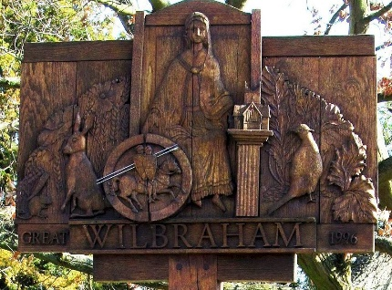

GREAT WILBRAHAM PARISH COUNCIL

Chairman: Dr Hilary Burton. Clerk: Mrs Sam Chambers-Turner

41 Stow Road

Stow-Cum-Quy

CB25 9AD

Tel: 07369248998

Email: clerkGW@wilbrahams.co.uk

NOTICE OF A MEETING OF THE PARISH COUNCIL

To Members of the Council:
I hereby give notice that a meeting of Great Wilbraham Parish Council will be held at Wilbrahams’ Memorial Hall on Thursday 15th June 2023 at 7.30pm

You are hereby summoned to attend for the purpose of transacting the following:
Members of the public and press are invited to attend.

Sam Chambers-Turner
Clerk to the Parish Council
10th June 2023

AGENDA FOR MEETING 15

- Apologies for Absence
(LGA 1972 s85(1)
- Members Declaration of Interest for Items on the Agenda and Requests for
Dispensation (Localism Act 2011 s31 s33)
- Open Forum for Public Participation (10 minutes)
At the close of this item, members of the public will no longer be permitted to
address the Council unless invited to do so by the Chairman.
- To Approve Minutes of Previous Meeting
Proposal: To Approve Minutes of Meeting 14, 25th May 2023.
- District and County Reports
- County Councillor Report
- District Councillor Reports
- Matters Arising/Chairman, Councillors and Clerk Reports including correspondence
received (for information only).
- Finances Including Approval of Payment of Outstanding Accounts
- Proposal: To Approve Bank Reconciliation for May 2023.
- Proposal: To Approve Payment of June 2023 Accounts.
- Proposal: To Approve and Chairman to sign the Annual Governance and Accountability Return

Payee | Description | Net | Vat | Gross
Mrs S Chambers-Turner | Clerks Salary June |  |  | Confidential
Opus | Street Lighting | £153.96 | £8.10 | £162.06
HSA | Payroll | £12.20 | £2.40 | £14.40
GCM | Grass Cutting | £397.20 | £79.45 | £476.65
ICCM | Membership | £95.00 | £0.00 | £95.00
LW & SMB | Warbler Share | £670.67 | £0.00 | £670.67
Burwell Print | Warbler Production 22383 | £851.77 | £0.00 | £851.77
 |  | £1108.19 | £179.00 | £1286.99

- Planning Matters
Planning Applications
23/01939/S73, Land North of Newmarket Road, Fen Ditton. To vary condition 1 of reserved matters application 20/02569/REM (Reserved matters application as part of phase 1B pursuant to condition 5 of outline planning permission S/2682/13/OL dated 30th November 2016 for detailed access, appearance, landscaping, layout and scale for the creation of 308 new homes, non-residential floor space, laying out of playing fields, open space, allotments, associated infrastructure and internal roads to replace six two storey houses (C2 and C3) within phase 1b with three storey houses and to replace five carports with garages.
23/02198/LBC 23 High Street, Great Wilbraham. Low pressure cleaning of internal beams currently painted with black and brown covering.
- Action Plan
- Proposal: To set up a working group for the management of an Action Plan.
- Proposal: To set a date for village walk about to review village assets.
- Jubilee Bench
To receive an update on the progress of purchasing a bench.
- Trees & Biodiversity
To receive a report from Councillor White.
- Cemetery
To receive a report from Councillor Harmer.
- Co-option
- Agenda Item for the Next Meeting
Any business and payments, to be considered at Parish Council meetings must be delivered to the Clerk for inclusion on the agenda at least 7 days prior to the meeting.
- Date of Next Meeting
Tuesday 11th June 2023, Full Parish Council at Wilbraham’s Memorial Hall.

