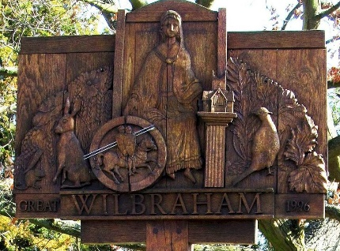

GREAT WILBRAHAM PARISH COUNCIL

Chairman: Dr Hilary Burton. Clerk: Mrs Sam Chambers-Turner

41 Stow Road

Stow-Cum-Quy

CB25 9AD

Tel: 07369248998

Email: clerkGW@wilbrahams.co.uk

NOTICE OF A MEETING OF THE PARISH COUNCIL

To Members of the Council:
I hereby give notice that a meeting of Great Wilbraham Parish Council will be held at Wilbrahams’ Memorial Hall on Thursday 18th May 2023 at 7.30pm

You are hereby summoned to attend for the purpose of transacting the following:
Members of the public and press are invited to attend.

Sam Chambers-Turner
Clerk to the Parish Council
11th May 2023

AGENDA FOR MEETING 14

- To Elect A Chairman
- Chairman to Sign Acceptance of Office
- To Elect a Vice Chairman
- Vice Chairman to Sign Acceptance of Office
- Apologies for Absence
(LGA 1972 s85(1)
- Members Declaration of Interest for Items on the Agenda and Requests for
Dispensation (Localism Act 2011 s31 s33)
- Open Forum for Public Participation (10 minutes)
At the close of this item, members of the public will no longer be permitted to
address the Council unless invited to do so by the Chairman.
- To Approve Minutes of Previous Meeting
Proposal: To Approve Minutes of Meeting 13, 20th April 2023.
- District and County Reports
- County Councillor Report
- District Councillor Reports
- Matters Arising/Chairman, Councillors and Clerk Reports including correspondence
received (for information only).
- Finances Including Approval of Payment of Outstanding Accounts
- Proposal: To Approve Bank Reconciliation for April 2023.
- To note date of Internal Audit.
- Proposal: To Approve Payment of May 2023 Accounts.

Payee | Description | Net | Vat | Gross
Mrs S Chambers-Turner | Clerks Salary May |  |  | Confidential
Opus | Street Lighting | £146.54 | £7.32 | £153.86
HSA | Payroll | £12.20 | £2.40 | £14.40
GCM | Grass Cutting | £696.40 | £139.28 | £835.68
AEDonate | Pads Defibrillator | £149.99 | £30.00 | £179.99
H Burton | Materials APM | £103.06 | £0.00 | £103.06
 |  | £1108.19 | £179.00 | £1286.99

- To Appoint Members to Working Groups and Committees.
- Policies
- Proposal: To review Standing Orders, Financial Regulations and Publication Scheme.
- Proposal: To create a policy document working group to review all policies and consider policies that require adoption.
- Wellbrahams
To receive a proposal from the Wellbrahams Group about a Sports and Creative Mindfulness Project.
- Planning Matters
Planning Applications
None
- Trees and Biodiversity
To receive a report on outstanding issues.
- Coronation
To receive an update on the Coronation Celebrations.
- Noticeboards
To receive quotations for replacement noticeboards.
- Highways, Transport and Cycleways Committee (HTCC) For information only
- To note the submission of the LHI 20mph application.
- To note correspondence received about night time diversions of the A11.
- To note the upcoming erection of bollards on Angle End and Mill Road.
- Six Oaks Energy
To receive information relating to the Six Oaks Energy proposal and consider community benefits.
Proposal: To work collaboratively with Little Wilbraham, Six Mile Bottom and Bottisham Parish Councils to negotiate the community benefits.
- Action Plan
- Proposal: To set up a working group for the management of an Action Plan.
- Proposal: To set a date for village walk about to review village assets.
- Jubilee Bench
To receive an update on the progress of purchasing a bench.
- Chalk Pits
To discuss recent correspondence about purchase of rental land at the Chalk Pits.
- Communications
To note the transition to Microsoft 365 and new email addresses.
- Cemetery
Proposal: To get Cemetery Software for the Parish Cemetery.
- Parish Council Vacancies
To discuss recruitment of new Parish Councillors.
- Community Coffee Mornings
To receive a proposal on Community Coffee Mornings from Councillor Burton.
- Agenda Item for the Next Meeting
Any business and payments, to be considered at Parish Council meetings must be delivered to the Clerk for inclusion on the agenda at least 7 days prior to the meeting.
- Date of Next Meeting
15th June 2023, Full Parish Council at Wilbrahams Memorial Hall.

