Each household produces 1 tonne of waste each year
We continue to be active on many fronts - here is a selection:-
Your Domestic Waste.
In January 22 members/supporters of WEG had a fascinating morning at Waterbeach learning what happens to the contents of our Bins. The site receives 3000 tonnes per week and the average household produces 1 tonne per year! The aim, of course, is to reduce what has to go into Landfill – and 55% of domestic waste is currently recycled – but we can all do better by reducing consumption (i.e. buying less “stuff”), re-using, repairing and recycling.
Black Bin waste, after metals and some other recyclable materials have been removed, normally ends up in Landfill (on the site) after it has been treated biologically in a tank to reduce its volume. At the moment, however, the processing plant is being enlarged and rebuilt and so, sadly for many months yet, the volume going straight into a large hole in the ground (the size of Wembley Stadium!) is huge.
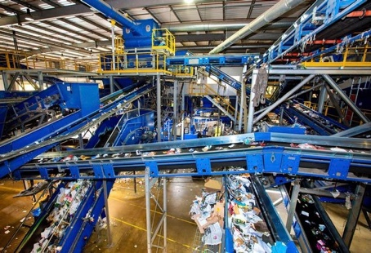
Blue Bin waste is treated in the “MRF” – Materials Recovery Facility – which we saw in operation. A combination of hand picking and machinery sorts paper, cardboard, metal, glass, steel and aluminium – and sorts plastic into 8 different types. Almost all of this is then despatched to other sites in the UK to be made into new products etc – except some paper and some plastic which is currently exported to Europe. None of our waste is processed or dumped in the Far East.
Green bin waste is rapidly converted into soil improver/compost – and is FREE for us. Just go to the site up the A10 (second roundabout) and collect what you want from a special heap near the gates.
2. Solar Farm.
The planning application (22/01291/ESF on the ECDC website) may be decided in the next month or two. We at WEG have met Ridge, the developers, again recently and (with some expert industry help) put to them a viable cabling route from the site to Cherry Hinton which would avoid our villages completely – we have our fingers crossed tight! We have also lobbied ECDC and Ridge for more biodiversity net gain on and near the site, and for the promise of annual community payments (somewhat like Wadlow Wind Farm) to be written into any Planning Consent.
3. Farming.
Continuing our dialogue with local farmers, we recently met up with Malek Hyde-Smith, Bidwells and James Kiddy who is now the contractor farming the Wilbraham Estate with continuing support from Phil Baynes who knows the farm (and its wildlife) inside out. James is making subtle but important changes which will improve the farm’s already substantial environmental credentials – e.g. by creating grass margins around fields, drilling new crops direct rather than first ploughing the land, and replacing much artificial fertiliser with natural sewage sludge. We should also soon see more livestock on the land which will surely gladden many hearts here.
4. Thermal Imaging.
Three of us have now been trained to use a special camera borrowed from Cambridge Carbon Footprint. We have helped a number of homeowners to see areas of heat loss, so that they can better insulate their homes. To show heat loss ideally the outdoor temperature needs to be 10 degrees colder than inside the home, so we may not be able to survey more homes until much later this year – but if you are interested please contact us.
5. The School.
We are delighted that the school is about to have lots of solar panels, new LED lighting and FIVE air source heat pumps – a giant step forward. We have introduced to the school the Waterbeach Waste Management Park and Ridge Clean Energy and anticipate that they will be coming to the school to talk to the children about (respectively) Waste and Renewable Energy.
JOIN US! TELL US WHAT INTERESTS YOU!! We are keen to involve everyone, young and old. Have a look at our section of the Wilbrahams website www.wilbrahams.co.uk/information/weg or contact us by email wilbrahamseg@gmail.com or ring 07594 601205 (Nick Toovey)

