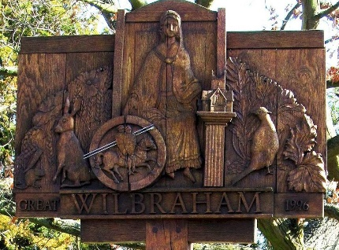

GREAT WILBRAHAM PARISH COUNCIL

Chairman: Dr Hilary Burton. Clerk: Mrs Sam Chambers-Turner

41 Stow Road

Stow-Cum-Quy

CB25 9AD

Tel: 07369248998

Email: clerkGW@wilbrahams.co.uk

NOTICE OF A MEETING OF THE PARISH COUNCIL

To Members of the Council:
I hereby give notice that a meeting of Great Wilbraham Parish Council will be held at Wilbrahams’ Memorial Hall on Thursday 16th February 2023 at 7.30pm

You are hereby summoned to attend for the purpose of transacting the following:
Members of the public and press are invited to attend.

Sam Chambers-Turner
Clerk to the Parish Council
10th February 2023

AGENDA FOR MEETING 8

- Apologies for Absence
(LGA 1972 s85(1)
- Members Declaration of Interest for Items on the Agenda and Requests for
Dispensation (Localism Act 2011 s31 s33)
- Open Forum for Public Participation (10 minutes)
At the close of this item, members of the public will no longer be permitted to
address the Council unless invited to do so by the Chairman.
- To Approve Minutes of Previous Meeting
Proposal: To Approve Minutes of Meeting 7, 19th January 2023.
- District and County Reports
- County Councillor Report
- District Councillor Reports
- Matters Arising/Chairman, Councillors and Clerk Reports including correspondence
received (for information only).
- Finances Including Approval of Payment of Outstanding Accounts
- Proposal: To Approve Bank Reconciliation for January 2023.
- Proposal: To Approve Payment of February 2023 Accounts.

Payee | Description | Net | Vat | Gross
Mrs S Chambers-Turner | Clerks Salary February |  |  | Confidential
Memorial Hall | Room Rental | £135.00 | £0.00 | £135.00

- Trees and Biodiversity
    - Trees on Frog End and Toft Lane.
    - To discuss communication received.
- MVAS
To discuss the delivery of the new MVAS units and the formation of a volunteer group.
- Carpenters Arms
To discuss current status.
- Communications
To receive a report from the Communications working group.
- Coronation
To further discuss Parish Council role in Wilbrahams Coronation celebrations.
To discuss the necessary budget that the Parish Council should make available to support Great Wilbraham celebrations.
- Software Provision
To receive further information on the status of transitions.
- Highways, Transport and Cycleways
To discuss communication received about the street cleaning schedules.
To discuss communication received about access to homes in Toft Way.
- Wilbrahams Refugee Support
To receive an update from Councillor Burton.
- Annual Parish Meeting
To confirm arrangements for the Annual Parish Meeting.
To discuss the necessary budget that the Parish Council should make available to support the Annual Parish meeting.
- CiLCA
To note the Clerk’s completion of the Certificate in Local Council Administration and consider adopting the General Power of Competence.
- Motion to Exclude
That the public (including representatives of the press) be excluded during the consideration of the remaining item No 5432 because it is likely, in view of the nature of the business to be transacted or the nature of the proceedings, that if members of the public were present during the item(s) there would be disclosure to them of exempt information of Category 1 & 2 Part 1 Schedule 12A to the Local Government Act 1972 (as amended).
- Clerks Review
To discuss appraisal.
- Agenda Item for the Next Meeting
Any business and payments, to be considered at Parish Council meetings must be delivered to the Clerk for inclusion on the agenda at least 7 days prior to the meeting.
- Date of Next Meeting
16th March 2023 at Wilbrahams Memorial Hall.
Annual Parish Meeting 30th March at Wilbrahams Memorial Hall.

