BOLLARDS BY THE SCHOOL

Many of us are quick to criticise the Highways Department, but in this case, our Local Highways Officer was even quicker in responding.

Andy Martin’s campaign for a zebra crossing outside the school continues. While looking at the possibilities, two TWG members noticed that the bollards were in a terrible state. Several were broken, others had reflectors missing, and all were filthy. They had become a hazard.

The situation was reported to Highways on Saturday 8th October by their web-site: https://highwaysreporting.cambridgeshire.gov.uk . On Monday 10th October, 4 new bollards and new reflectors had been installed. Two days later, TWG completed the improvement by donning a yellow jacket and washing down the bollards and the old reflectors. [Scrubbing would have been better, but that is for another day.]

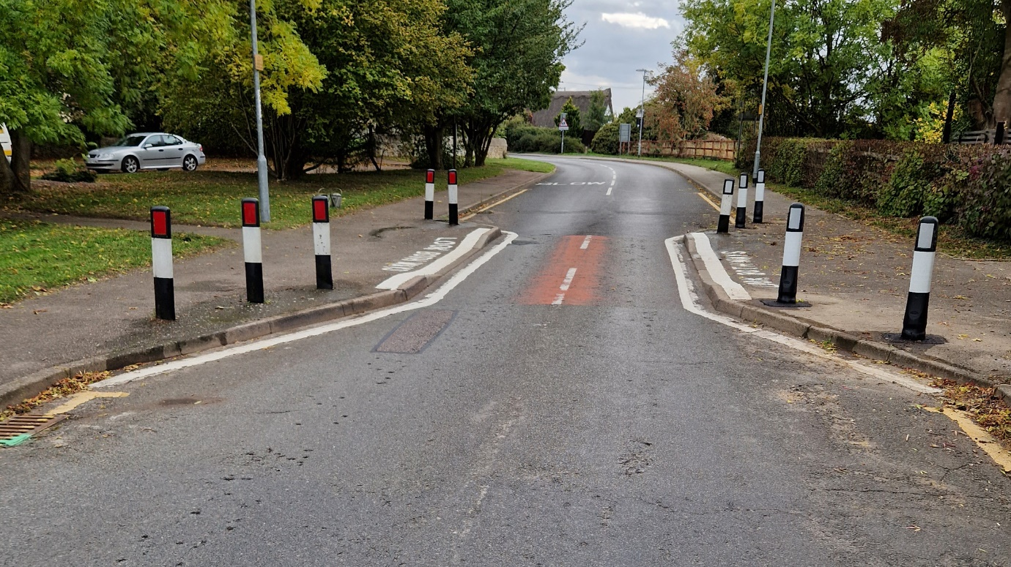

Transformation complete. But please please remember that this is not an official crossing point for pedestrians. Children can so easily forget.

DLR. TWG. 12 October 2022.

