Your Parish Council is
planning for the future!

How should Great Wilbraham develop
in the years ahead?

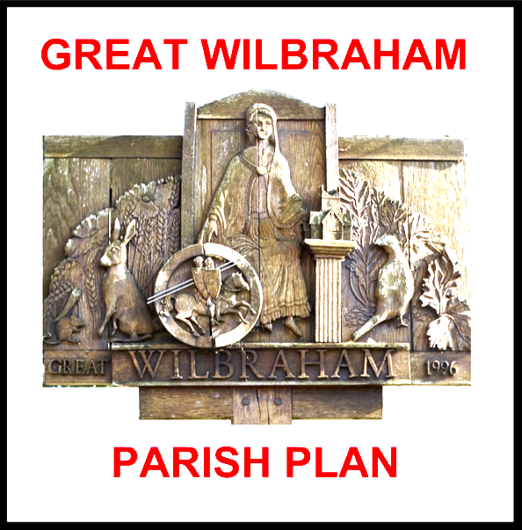

Tell us about your ambitions for the village and find out how to get involved in making them happen

Meet us at the Great Wilbraham Parish Council’s stall at the Farmer’s Market

Saturday 10 September
10.00am to 12.00pm

