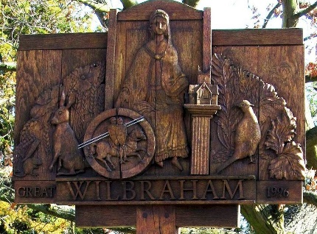

GREAT WILBRAHAM PARISH COUNCIL

Chairman: Mrs Sally Ramus. Clerk: Mrs Sam Chambers-Turner

41 Stow Road

Stow-Cum-Quy

CB25 9AD

Tel: 07369248998

Email: clerkGW@wilbrahams.co.uk

NOTICE OF A MEETING OF THE PARISH COUNCIL

To Members of the Council:
I hereby give notice that a meeting of Great Wilbraham Parish Council will be held at Wilbrahams’ Memorial Hall on Thursday 4th August 2022 at 7.00pm

You are hereby summoned to attend for the purpose of transacting the following:
Members of the public and press are invited to attend.

Sam Chambers-Turner
Clerk to the Parish Council
29th July 2022

AGENDA FOR MEETING 4

54. Apologies for Absence
(LGA 1972 s85(1)
55. Members Declaration of Interest for Items on the Agenda and Requests for Dispensation
(Localism Act 2011 s31 s33)
56. Planning
Applications
22/02411/HFUL 58 High Street, Great Wilbraham. Removal of existing single storey
rear garden room and replacement with single storey extension.
22/02947/FUL Land at the back of Frog End, Great Wilbraham. Construction of a detached one and half storey two bedroom dwelling.
57. Matters for Future Consideration
58. Agenda Items for the Next Meeting
Any business and payments, to be considered at Parish Council meetings must be delivered to the Clerk for inclusion on the agenda at least 7 days prior to the meeting.
59. Date of Next Meeting
Parish Council Meeting, 7.30pm on 15th September 2022 at Wilbrahams’ Memorial
Hall.

