Here is a postcard of the Chapel sent in about 1912.
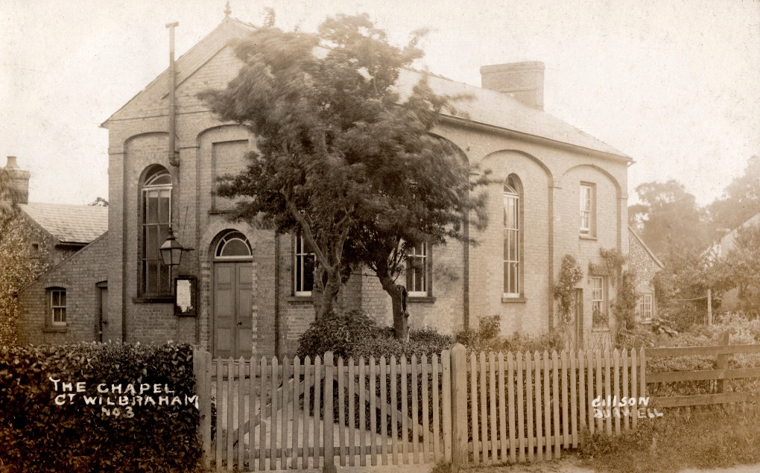

It was sent from Great Wilbraham to a Miss Crowe in Grantham, possibly a young niece of the ‘Uncle’:

“My dear Hilda Uncle and I were very delighted to hear from you dear. Am spending a nice quiet Holiday with him. Of [course] I miss you dear but still that can't be helped. Am sending you card of Chapel as you ask dear. Hope you will put it in your Album & take care of it Best love from dear Uncle & myself Aggie.”

The Baptist Chapel was built in about 1833 to seat between 60 and 80, although in 1851 the congregation was down to between 30 and 50, and had fallen again to about 12 by 1885. The Chapel closed briefly in 1894 but was revived by the Baptist Cambridge Village Preachers Association and formed part of the Cherry Hinton group in the early 20th century. Older residents may be able to confirm that there was still a Baptist Sunday school in 1970 when the congregation was up to 45. I have found a story that in 1980 the pastor was converted to an American sect and gave over the chapel to new-style services, involving chanting and guitar playing. In 1981 he was ejected!

My memory of the event is none too good, but I believe the Chapel closed in about 1990.

