Superstar, stupendous, superlative Sally.

Tippen Towers is positively throbbing with excitement this week. No Roddy hasn't done the washing up, but he is living with an international and national silver and gold medalist hockey player, Sally.
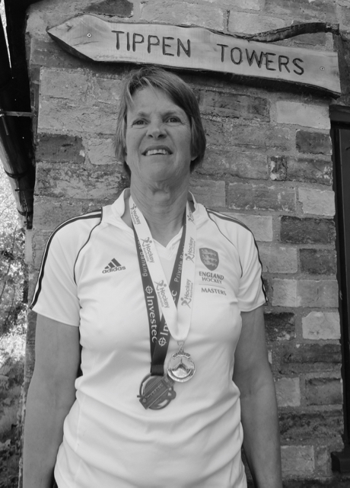
Tippen Towers, or more specifically beloved Ringo, was bereft when Sally and Roddy went to Australia at the beginning of April. She had been selected to represent England and compete in the Masters Hockey World Cup, held in Canberra, Australia. Not only was she a team member of the England Over 60's national team, never one to do things by half she was also Vice Captain.
The team played 5 games and won 4, reaching the World Cup Final to face New Zealand. In a thrilling match, there were chances for both teams, but it wasn't until the last two minutes that New Zealand broke the deadlock with a well placed goal from a short corner to win 1-0. England could congratulate themselves for playing fantastically throughout the tournament and being awarded silver. Well done Sally.
But this wasn't enough for superstar Sally. On the 29 April still jet lagged she set off to play for her club, Cambridge City, in the Over 45's Women's National Cup final. The venue was the impressive National Hockey Centre at Lee Valley Stadium the site of the 2012 Olympics. Last year Cambridge City lost in the final so this year they were determined to get gold. Fresh from her success in Australia, Sally helped her team snatch a well- deserved 2-1 victory from their opponents, Kettering HC. Sally received her national gold medal which shares pride of place with her international silver.
We're just waiting to see if Roddy can gain inspiration from his wife and score another century this year for the Wilbrahams' Cricket Club.
Jo Bray

