DEFIBRILLATOR
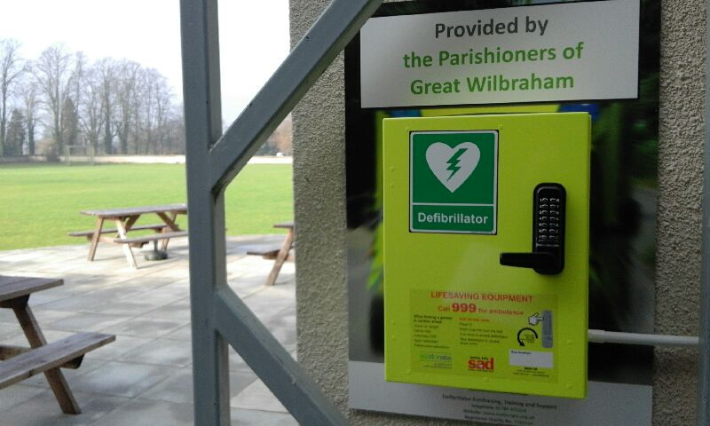
TRAINING 13 February 7pm Wilbrahams’ Memorial Hall
You may have noticed the defibrillator now in place on the wall between the Memorial Hall and the Social Club. It has been provided by Great Wilbraham Parish Council, helped by a very generous donation by Claire Jackman.
Anyone of any age can suffer a sudden collapse and a cardiac malfunction or arrest. Using the defibrillator can literally save a life. It is very easy to use and anyone can do it. You don't need training as the machine tells you what to do. However, to increase people's confidence and understanding of sudden collapse caused by heart problems we have arranged training. This will take place in the Memorial Hall at 7pm on 13 February, Monday. Appropriately, the day before Valentine's Day, when many hearts will be fluttering. We'll look forward to seeing you at the training.
